Computer Programming & Problem Solving

1. Write a java program that will print “Hello” and then print your First name on a separate line and your last name on a separate line as well.

Expected Output example

Hello

Mark Joseph

Beldad

1. Write a java program that will output the result of 20 + -5*20 / 4

Expected Output: -5

1. Write a java program that will output “Hello World” but your name is included in the source code.

Expected Output: Hello World

1. Write a java program that will output the product of 13 and 5.

Expected Output: 65

1. Write a java program that will output the quotient of 120 and 6.

Expected Output: 20

**Note:** Please put the codes in a word file and save the file following the format <Lastname Firstname>-DSA-Prelim (e.g., Beldad Mark Joseph-DSA-Prelim) and send it to [mbeldad@tfvc.edu.ph](mailto:mbeldad@tfvc.edu.ph) via email.

1.public class App {

    public static void main(String[] args) throws Exception {

        System.out.println("Hello");

        System.out.println("Clifford");

        System.out.println("Villena");

    }

}

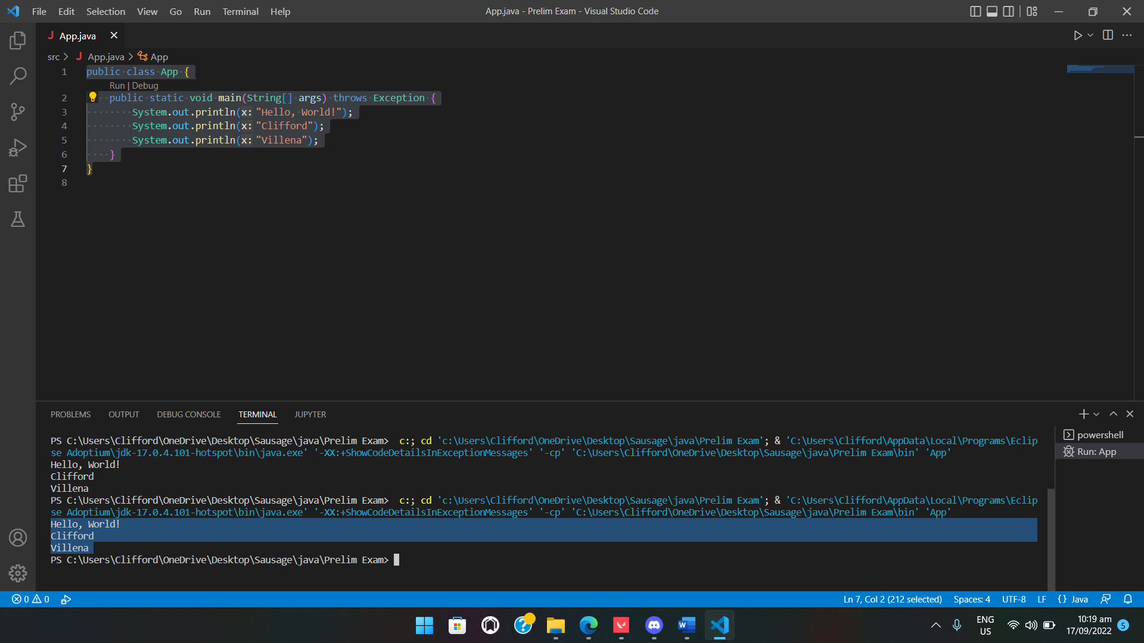

2. public class App {

    public static void main(String[] args) throws Exception {

    int a = 20, b = -5, c = 20, d = 4;

    float e;

        e = a + b * c / d;

        System.out.print("Answer:" +e);

}

}

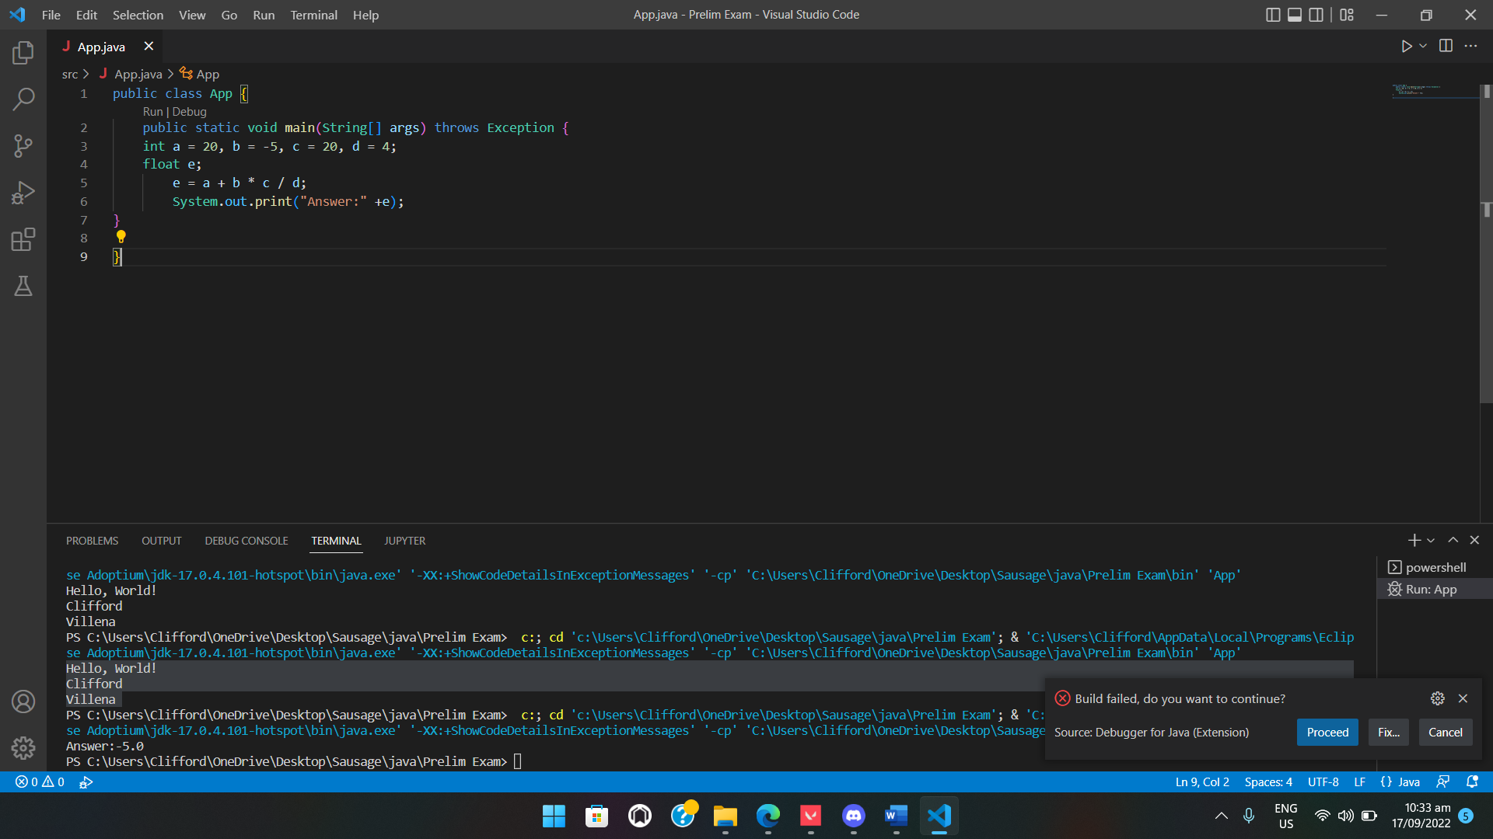

3. public class App {

    public static void main(String[] args) throws Exception {

        /*Clifford T. Villena */

        System.out.println("Hello World");

}

}

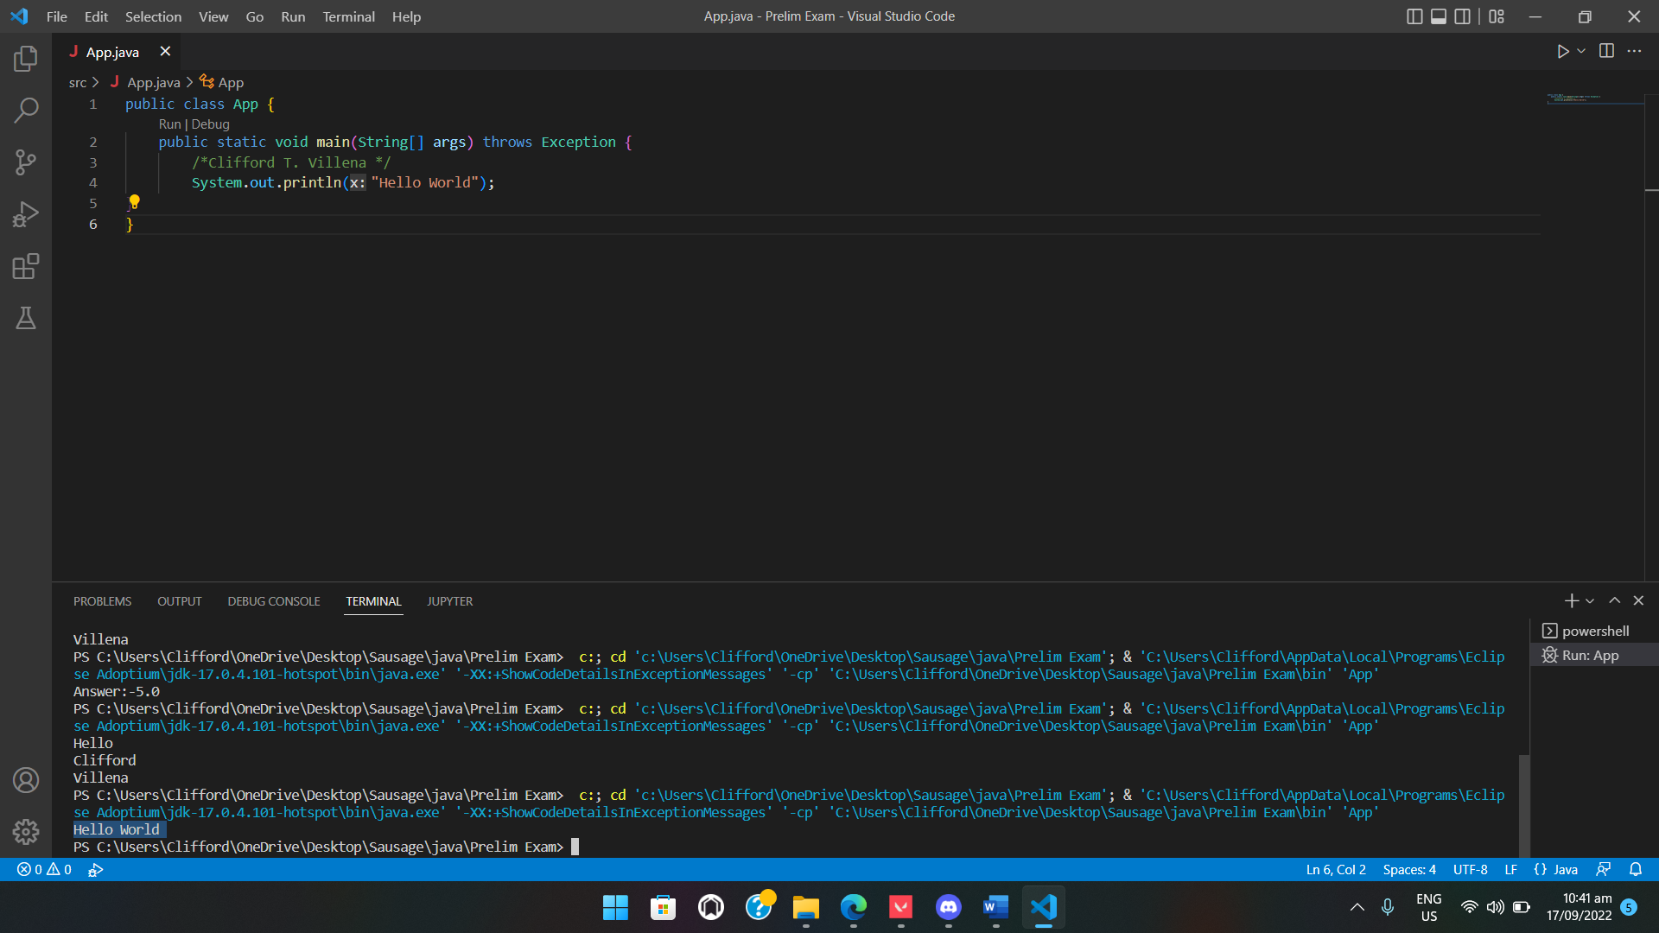

4. public class App {

    public static void main(String[] args) throws Exception {

    int a = 13, b = 5, c;

    c = a * b;

        System.out.print("Answer: " +c);

}

}

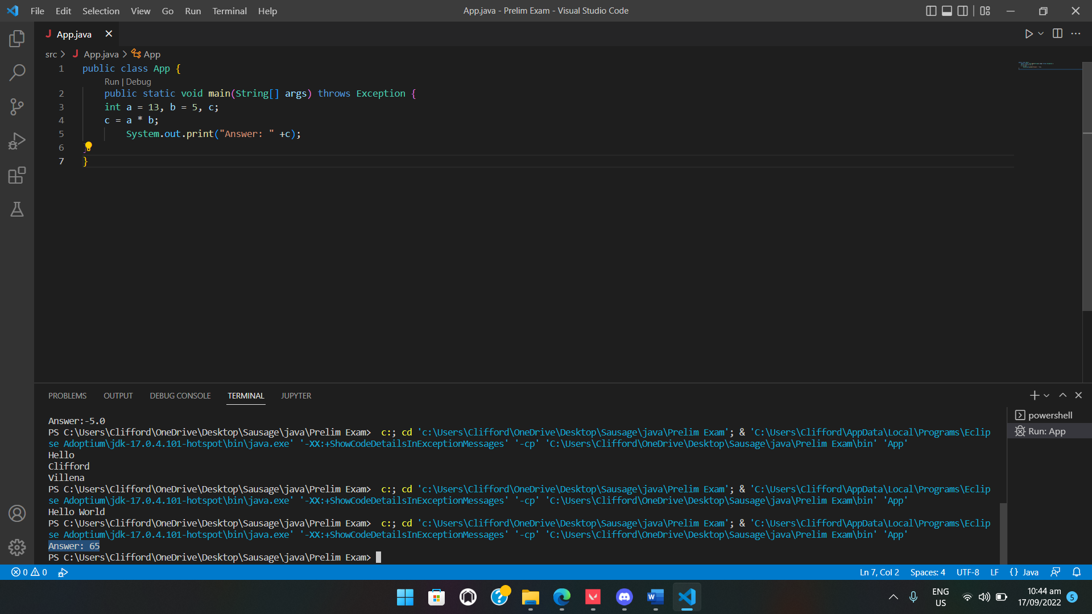

5. public class App {

    public static void main(String[] args) throws Exception {

    int a = 120, b = 6;

    float c;

    c = a / b;

        System.out.print("Answer: " +c);

}

}

